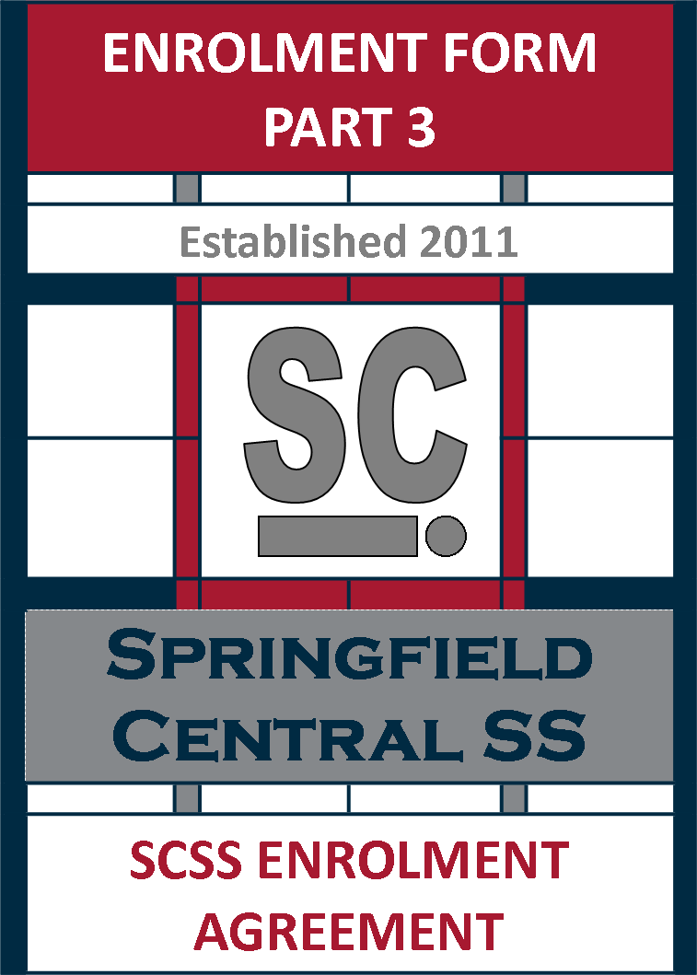

STUDENT NAME:

Welcome to Springfield Central State School. We look forward to working together with you and your family help our school community achieve our motto: “Raise the Bar”

This enrolment agreement sets out the responsibilities of students, parents and staff about the education of students enrolled at Springfield Central State School.

Our school policies and procedures are developed collaboratively with our school community. When they are approved for implementation they are posted on our school website and all members of our school community are encouraged to access them.

On request the Principal (or delegate) will also provide a full hard copy of any of our school policies; and by appointment, the Principal (or delegate) is also available for any follow-up discussion if required.

As a government school we also implement other relevant state and commonwealth policies and procedures.

OUR RESPONSIBILITIES
STUDENTS   attend school regularly, on time, ready to learn and take part in school activities   be self-managed and at all times adhere to our Code of Conduct and Courtesy   work hard and always aim to raise the bar for yourself and your learning   abide by the school rules and meet homework requirements   wear the full school uniform at all times   respect our school environment | SCHOOL   develop each individual student’s talents as fully as possible   provide an environment where staff can teach and students can learn   inform parents and carers regularly about how their child/ren are progressing   inform parents and carers of medium and high level behaviours   contact parents and carers if there is a concern about school work, attendance or punctuality   teach effectively and set the highest standards in work and behaviour   take reasonable steps to ensure the safety, happiness and self-confidence of all students   be open and welcoming to parents (outside of learning time) and offer opportunities for parents and carers to become involved in the school community   clearly articulate the school’s expectations regarding the responsible behaviour plan and the school’s dress code policy   deal with complaints and complexities in an open, fair and transparent manner   consult parents on any major issues affecting students   treat students, staff and parents with respect and tolerance
PARENTS
 inform the school of any absences and provide reason
 ensure your child is at school ready to learn on the first bell
 treat school staff with respect and tolerance
 let the school know if there are any problems that may affect your child’s ability to learn
 inform school if your child’s living arrangements change and provide details of changes
 Ensure that students are not dropped at school before 8:30am and are collected from school as close to 2:45 pm as possible (note: there is no supervision for students before the bell goes in the mornings)
 abide by the school’s policy regarding access to school grounds before, during and after school hours.
 Attend school functions where possible
 Ensure that their children comply with the dress code for students

I have read and accept the rules and regulations of The Springfield Central Way as stated in the school policies (available on the website)
- Responsible Behaviour Plan
- Student Dress Code
- Homework Policy
- School charges and Voluntary Contributions (EE4L and Keeping SCSS State of the Art)
- Student Use of ICTs
- Process for student absences
- Religious Instruction in school hours
- Bell Times and note: students not to arrive before 8:30am

PARENT/GUARDIAN NAME: | DATE:
Parent/Guardian to sign at enrolment interview:

SCSS Enrolment Agreement

STUDENT NAME: | YES or No
ANAPHYLAXIS
My child requires an individual Anaphylactic Plan.
ASTHMA
In Relation to Asthma my child in in the following category:
A. Child is authorised by parent to self-administer Asthma medication as needed and is also authorised to be responsible for caring for the medication. Please see the Principal (or delegate)
B. Child is authorised by parent to self-administer Asthma medication as needed but with adult supervision. Medication to be left at office.
C. Parent/carer requires that the child’s Asthma medication be held at the office and administered by an adult
D. The child has mild Asthma only. In the event of an attack the child’s parent authorises their child to be administered medication by an adult and understands that a parent or other emergency contact will be notified.
E. Child does not have Asthma
CHANGE OF PERSONAL DETAILS
I will notify the school of any changes in personal details (i.e. address, contact phone numbers, etc) immediately so that accurate records can be maintained particularly in the case of emergency.
ELECTRONIC COMMUNICATION
I understand that the school communicates upcoming events, activities and general newsletter items on the website via ‘news items, calendar and principal’s blog’. The school will also communicate information via e-mail, SCSS App and Facebook. I commit to regularly checking at least one form of digital communication.
HEADLICE
I agree to my child having their hair checked if it is suspected they have head lice, to be contacted to pick them up if necessary, and to appropriately treat their hair prior to returning them to school. I understand that if reported, a headlice alert notification will be sent via e-mail to child’s class.
HOMEWORK
I agree to support my child in completing their homework and ensuring it is handed in by the due date. I am aware of the school guidelines for homework and accept the consequences of not handing in homework.
MEDICATION
If my child needs medication while at school, I understand that the school staff will only administer over the counter or prescribed medication if:
✓ I fully complete a School Medication form
✓ I supply written advice from a medical practitioner
✓ I supply the medication in the original labelled container
PRIVACY STATEMENT
I am aware of Education Queensland’s Privacy Statement
RELIGIOUS EDUCATION
SCSS offers Cooperative Ecumenical Religious Education for 30 minutes a week during school hours for years 1-6. Lessons are conducted by volunteers approved by local churches and endorsed by Education Queensland. Classroom teachers will co-supervise all lessons.
Do you give permission for your child to participate in the Co-operative Religious Education Program for 30 min a week?
RESPONSIBLE BEHAVIOUR PLAN FOR STUDENTS
I agree to follow the school Responsible Behaviour Plan for Students.
STUDENT DRESS CODE AND SUN SAFETY
I agree to follow and support the Student Dress Code and Sun Safety guidelines. I understand and support the sanctions in response to a uniform breach.
STUDENT USE OF ICTs
I understand my child’s responsibility in regards to the use of ICT devices and access to the internet. I hereby give permission for my child to access the internet under the school rules.
SUSPENSIONS/EXCLUSIONS
My child is not currently suspended or excluded from any other Educational Institution.
I have notified the Principal at SCSS of any previous suspensions/exclusions from any other Educational Institution. Please list:

I hereby declare that the information given is true and correct as at the date of enrolment

PARENT/GUARDIAN NAME: | DATE:
Parent/Guardian to sign:

STUDENT ICT & Internet Usage Agreement

Springfield Central State School prides itself in being a Technology and Thinking School. Students have regular daily access to ICTs including computers, laptops, digital devices, interactive technology, digital and video cameras, scanners, printers, the internet, e-mail, web based programs, robotics equipment and software.

It is our aim that students are confident and competent in the use of ICTs as a means of enhancing engagement and maximising learning outcomes. We are proud to have Techno Literate Teachers that cater for the needs of our generation z learners. Students will be trusted to handle and manipulate expensive digital equipment and to access internet information independently. The use of such equipment and access to the internet and e-mail at Springfield Central State School is a privilege. We ask that all students in Years 3-6 understand that with this privilege comes responsibilities.

IN USING ICT RESOURCES APPROPRIATE FOR ALL LEARNING TASKS I WILL:
✓ Be considerate of other users. I will respect their privacy and not seek access to files or messages intended for, or belonging to others.
✓ Virus check discs and USBs before use on the school network.
✓ Not attempt to create, copy or transfer computer viruses.
✓ Report any damage, errors or faults with ICTs to my teacher immediately.
✓ Not store illegal copies of mp3 songs on any data device that I use at school.
✓ Report accidental access to controversial, inappropriate or offensive materials to my teacher.
✓ Only ever use my own log on (unless directed by a teacher) and be discreet with my password.
✓ Use my printing budget sensibly and only print material related to my education.
✓ Not access any social networking sites from the school network.

I WILL NOT USE ICT RESOURCES TO:
✓ Access, copy or distribute any material that is controversial, inappropriate, obscene or offensive.
✓ Download or install any software, exe files or programs that violate copyright, intellectual property or licensing laws.
✓ Access streaming media such as sounds, music, video or games without teacher consent.
✓ Access the control panel, systems configuration, or make any changes to settings or passwords (other than my own).
✓ Directly or indirectly access drives other than those allocated to me.
✓ Directly or indirectly move, delete or modify files that I am not the author of.
✓ Be involved with electronic or physical vandalism, harassment or bullying in any form (this includes the use of your school MIS account out of school hours).
✓ Use, manipulate or transmit photos of members of students or staff without their (and their teacher’s) approval.
✓ Reveal my full name, personal address, phone number or those of my friends or staff in any electronic communication.

Teachers, parents and officials have the right to access and inspect contents of student electronic files, folders, storage devices and e-mail accounts at any time. Random audits of student files will be carried out on a regular basis. Students found to be violating this policy or any law will receive appropriate consequences.

I accept the above responsibilities and that breaching this agreement will result in me losing access to ICT resources temporarily or permanently, depending on the seriousness of the offence.
Student Signature & Date
I hereby declare that I have read and I accept the above agreement
I accept that while teachers always exercise their duty of care, protection against exposure to harmful and inappropriate information and pictures depends upon responsible and informed use by my child.
I believe my child understands his/her responsibilities and I hereby:
✓ give permission for my child to access, produce and communicate information on the internet,
✓ give permission for my child’s photograph to be displayed where appropriate, on web pages and virtual classrooms made by teachers and students,
✓ understand and accept that my child’s folders, files and storage devices will be checked by the system administrator and by teachers/admin if required.

PARENT/GUARDIAN NAME: | DATE:
Parent/Guardian to sign:

