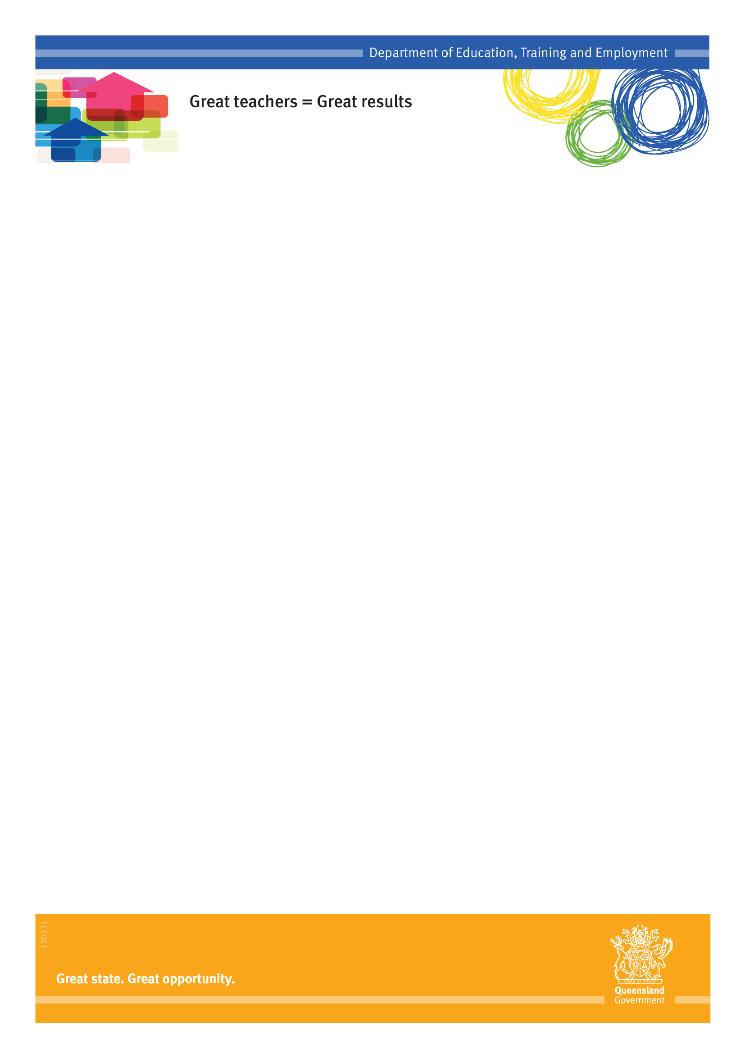
Under the Education (General Provisions) Act 2006, the Chief Executive may establish a school council for a state school.
Queensland School Councils
Fact Sheet
Independent Public Schools
Composition
Fact Sheet
Independent Public Schools
The number of members of a school council must be at least six and not more than fifteen.
A school council must include at least:
- one elected parent member
- one elected staff member (the number of elected parent members and elected staff members of a school council must be equal).
A school council must include not more than:
- two elected student members
- two appointed members.
A school council must include at least:
- one elected student member (if the state school provides years 10, 11 or 12).
The official members of a school council are:
- the school principal
- the Parents & Citizens’ (P&C) Association president.
All members of a school council (except co-opted student members – that is, students not in Years 10, 11 or 12) are able to vote at council meetings.
Chairperson
Independent Public Schools
Fact Sheet
A school council must elect one of the council’s members as chairperson of the council. The school’s principal may not be elected as chairperson, however the P&C president is eligible.

Functions
Fact Sheet
The role of a school council is to:
- monitor the school’s strategic direction
- approve:
- plans and policies of the school of a strategic nature
- other documents affecting strategic matters, including the annual estimate of revenue and expenditure for the school.
- Monitor the implementation of the plans, policies and other documents mentioned above
- Advise the school principal about strategic matters.
The council must perform its functions in a way that achieves the best learning outcomes for the school’s students.
Term of Office
Fact Sheet
Each elected member, or appointed member, of a school council holds office for the term, not longer than two years, stated in the council’s constitution.
However, if newly established, the council’s constitution may provide for half of the first elected members to hold office for a term of not longer than three years.
Meetings
Fact Sheet
A school council must meet at least twice in each semester.
The school council’s chairperson must preside over all council meetings at which the chairperson is present.
A question at a school council meeting, other than a question about an amendment of the council’s constitution, must be decided by a majority of the votes of the council members present.
Legal Accountabilities
A member of a school council does not incur civil liability for an act done, or omission made, honestly and without negligence under the Education (General Provisions) Act 2006.
School council documents are subject to Right to Information obligations. Further information can be found at http://deta.qld.gov.au/right-to-information/
Role of the P&C
School councils will have the responsibility to approve the strategic documents that set the direction, culture and tone of the school. The P&C president will be on the school council to represent the views of the P&C Association.
The Independent Public Schools initiative will not have any impact on the functions of P&Cs.
Out of Scope
A school council cannot:
- interfere with management by the school’s principal of day-to-day operations of the school and its curriculum
- make operational decisions about the use of teaching or learning resources at the school
- make decisions about the individual teaching style used, or to be used, at the school
- make a decision that is contrary to law or a written policy of the department
- control funds
- enter into contracts
- acquire, hold, dispose of or deal with propery
- sue or be sued
- establish a committee or subcommittee.
Want to know more?
For more information about the Independent Public Schools initiative, visit the Education Queensland website at:
www.education.qld.gov.au/schools/independent-public-schools/index.html
or email: IPS@dete.qld.gov.au

