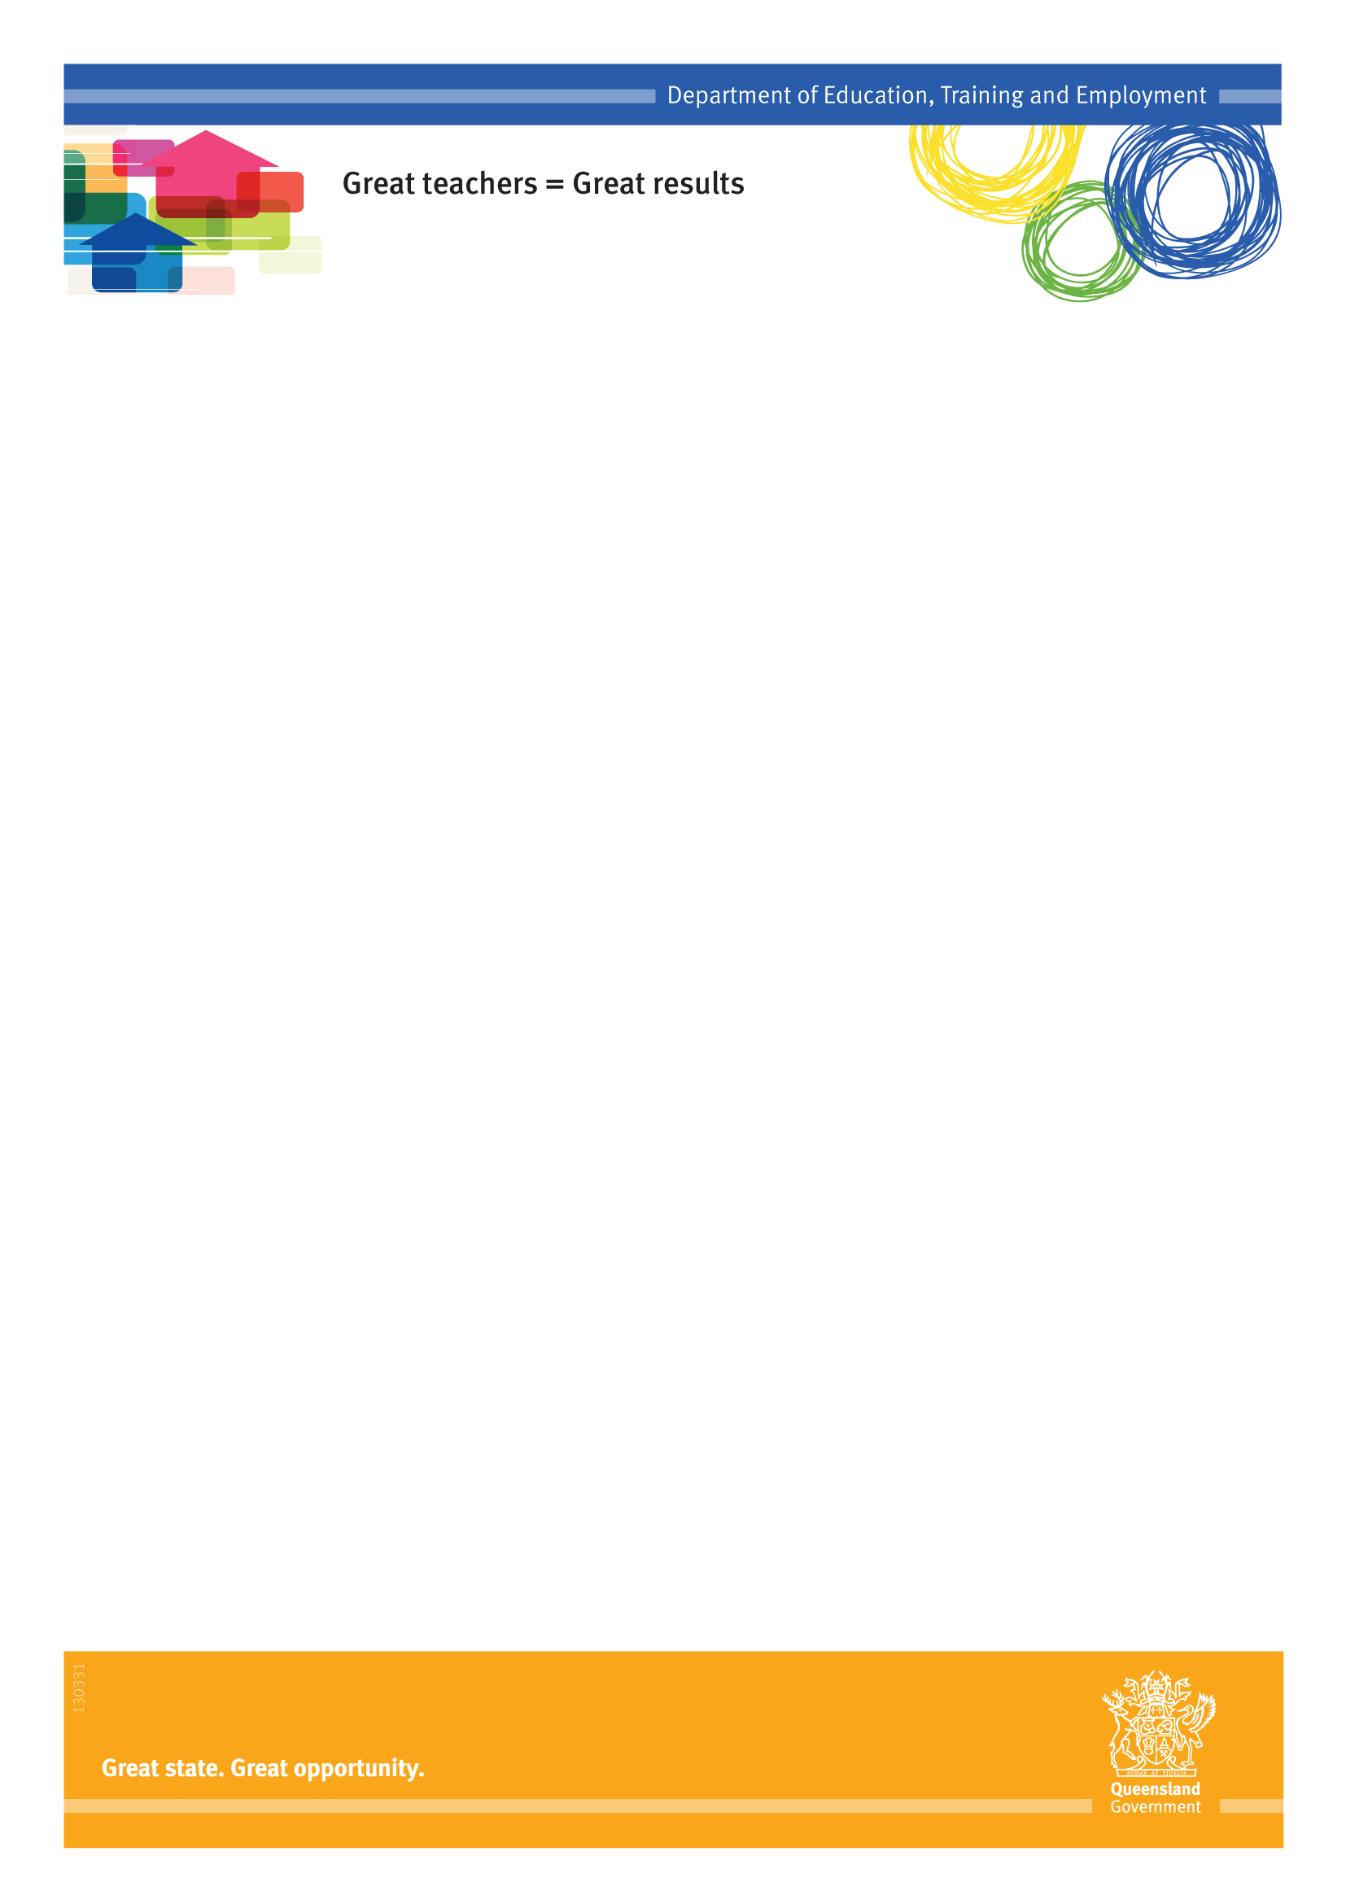
How do Queensland Independent Public Schools differ from other state schools?
Questions and Answers for Schools

Fact Sheet
Independent Public Schools
Queensland Independent Public Schools have greater flexibility to enable innovation that improves performance through:
- managing their planning and review processes
- determining staffing options
- determining the departmental policies and procedures that best suit their individual communities.
All Independent Public Schools remain part of the strong state school system. They need to operate within the system enacting the same core values, beliefs and priorities.
How can schools become an Independent Public School?
All Queensland state schools, irrespective of size, geographical location or school type, can apply to become an Independent Public School in 2015 through an open Expression of Interest (EOI) process.
Prior to submitting an EOI, it is essential that principals undertake broad consultation with their school communities.
Principals may use existing consultative groups to ensure the whole school community has the opportunity to provide input and to gain an understanding of all stakeholder views.
Schools can begin their consultation at any time.
Consultation will gauge community interest in becoming an Independent Public School.
School consultation should involve stakeholders such as:
- staff
- parents, including the Parents & Citizens’ Association and school council (if established)
- the wider community, for example local business, industry and community groups.
When submitting an EOI, schools need to provide documentation of no more than three A4 pages to demonstrate:
- the consultation that has occurred across groups, including a summary of their views
- the school’s capacity to assume greater responsibility for their affairs
- the potential benefits for students and the broader school community
- the innovative educational programs or practices that the school will implement to improve student performance.
All applications must be submitted using the online form which will be made available on OnePortal during the submission period.
How are schools selected for the initiative?
A Department of Education, Training and Employment internal panel, including a number of existing IPS principals, considers all Independent Public School applications. Schools that are in the best position to use increased autonomy to improve student outcomes are selected. Additionally, the schools selected represent the diversity of state schools across Queensland, with schools in every region encouraged to apply.
To assist in the selection of schools, the panel may source additional information including:
- school performance data
Independent Public Schools
- school financial audit reports.
How many schools are involved?
There is an opportunity for at least 120 schools to become Independent Public Schools over a four-year period from 2013 to 2016. There are currently 80 schools involved in the program with 26 selected in 2013 and 54 in 2014.
Further opportunities to express interest to become an Independent Public School will be provided each year, until 2016.
From 2017, the Independent Public Schools program will be expanded through Great teachers=Great results.
What does school governance look like in an Independent Public School?
Independent Public Schools are required to have a school council. This enables greater involvement of the school community and other stakeholders, such as industry, in setting the strategic direction of the school. School councils approve and monitor the school’s strategic direction, strengthening local decision-making.
In addition, principals have a performance agreement with the Director-General.
Are Independent Public Schools funded differently?
Independent Public Schools receive a one-off $50,000 grant in Term 4 of the year prior to commencement as an Independent Public School to assist with their transition. Schools will also receive an annual grant of $50,000 paid in Term 1. Independent Public Schools continue to receive funding according to departmental allocation methods.
Fact Sheet
How do staffing processes differ for Independent Public Schools?
Principals at Independent Public Schools can choose between directly recruiting teachers (where vacancies exist) or by filling vacancies through existing department applicant pools or the transfer system. They can also access the relocation process for classified teaching staff.
Independent Public Schools can shape their workforce to meet strategic directions set at a local level that respond directly to the needs of their students. Schools have additional autonomy for greater flexibility in staffing options through:
- direct recruitment of classified and non-classified teaching staff at any time
- local management of their staffing profile.
The Independent Public School initiative does not impact staff permanency. If a permanent employee does not wish to remain in an Independent Public School, they have the opportunity to transfer to another state school within the same geographic area.
All permanent employees are required to confirm in writing if they are opting out from their school within one month of the notification that the school will be included in the Independent Public Schools initiative.
Independent Public Schools
Fact Sheet
The transfer system is available for Independent Public School teachers who wish to move to other locations.
How are Independent Public School facilities managed?
Independent Public Schools can formulate infrastructure plans and industry links to shape a physical environment that best matches the strategic vision for their school. Schools:
- can make local decisions about joint facility agreements and partnerships
- can contract and manage their own maintenance using QBuild or contractors
- develop a Strategic Infrastructure (Assets) Plan in direct consultation with Central Office
- submit requests for capital works projects directly to Central Office.
An Independent Public School that is subject to a Public Private Partnership (PPP) is obligated to comply with the PPP contract conditions. For example, a PPP School is not required to formulate a maintenance or Infrastructure (Asset) Plan and these are incorporated into the PPP arrangements. The PPP contract would also continue to be managed centrally by the department.
How are Principals of Independent Public Schools Employed?
Principals of Independent Public Schools are employed under existing conditions. This means they apply for relocations or promotions through existing processes.
The Independent Public Schools initiative has no impact on the banding of the principal position.
The school council chair or their nominee is included in the selection panel of a principal in an Independent Public School.
How are Independent Public Schools accountable?
As part of Queensland’s strong state education system, Independent Public Schools are required to comply with all national and state legislation, industrial instruments, directives, delegations, whole-of-government policy and national agreements. They are also required to participate in all departmental audits.
While Independent Public Schools are not required to follow a number of operational procedures, they are required to:
- determine and manage their planning and review processes for the school
- participate in system audits
- provide systemic data and use corporate systems, for example OneSchool and MyHR
- purchase IT products that are compatible with the department’s managed operating environment
Independent Public School principals enter into a performance agreement with the Director-General.
Fact Sheet
Independent Public Schools
The school council monitors and endorses school performance against planned targets.
Do Independent Public Schools follow departmental policies?
While Independent Public Schools are not required to follow a number of operational procedures, they are required to operate within legislation, industrial instruments, directives, delegations, whole-of-government policy and national agreements.
Further information can be found in the Legislative and Policy Requirements fact sheet.
What curriculum do Independent Public Schools deliver?
Within a curriculum framework approved by the Minister, Independent Public School principals plan the learning experiences offered to students at a school. This means implementing the Australian Curriculum, the Queensland Studies Authority syllabuses and mandatory languages other than English in Years 6, 7 and 8.
What are the enrolment processes for Independent Public Schools?
Independent Public Schools manage their enrolments within existing capacity and enrolment management plans. Special school principals involved in the Independent Public Schools initiative make recommendations to the Deputy Director-General - State Schools regarding the enrolment of students at their school.
Can Independent Public Schools charge additional fees?
As with all state schools, Independent Public Schools determine student resource scheme amounts, voluntary contributions or set fees for specialised programs.
Can Independent Public Schools change their name?
No. The authority to change the name of a state school remains with the Minister.
What support is provided to Independent Public Schools?
Independent Public Schools receive a $50,000 grant to assist with their transition. This funding enables schools to seek expertise and advice about the establishment and effective functioning of their school council. In addition, schools will receive a further $50,000 in funding each year.
Independent Public Schools benefit from the strengths of the Queensland state education system through access to:
- existing liability insurance
- legal and media advice
- financial and purchasing advice
- industrial relations advice and support
- Curriculum into the Classroom
- OneSchool
- MyHR
- Workcover support
- central and regional office support.
How do school councils operate?
School councils in Independent Public Schools operate under the existing legislation as applied to all state schools. The establishment of school councils allows greater involvement of the school community in determining the school’s strategic direction.
Independent Public Schools
Fact Sheet
School councils comprise at least six, but not more than 15 members. A school council must include at least one elected parent member and one elected staff member (the number of elected parent members and elected staff members of a school council must be equal).
A school council (for a school that provides Years 10, 11 and 12) must include at least one but not more than two elected student members and two appointed members. Elected student members can only be students from Year 10, 11 or 12 at the school. Schools may appoint coopted students from younger year levels, however these students are unable to vote.
In general, the school council plays a role in approving and monitoring the school’s strategic direction in a way that achieves the best learning outcomes for the school’s students. The size of the school will determine representation of staff and students on the school council.
For more information read the Queensland school councils fact sheet.
How does the role of a school council differ to that of a P&C?
The school council has an accountability role and is responsible for informing and monitoring the school’s strategic direction. Members are responsible for approving strategic documents that set the direction, culture and tone of the school.
The Parents and Citizens’ (P&C) Association has a support and advice role and is responsible for school fundraising activities.
The Independent Public Schools initiative does not impact on the functions of P&Cs.
Is the Independent Public Schools initiative supported by research?
Research on school autonomy shows its success relies on a range of factors such as what support is provided, types of autonomy, accountabilities, etc.
However, research also shows that while there should not be a ‘one-size fits all’ model for autonomy, there is a link between principal autonomy and school effectiveness. In addition, a 2011 study by the Organisation for Economic Cooperation and Development reports that a combination of autonomy and accountability is related to better student outcomes.
The level of autonomy required by schools is dependent on a complex mix of variables such as community aspiration, student cohort, geography, etc. The increased level of autonomy that will be offered by the Independent Public Schools initiative has the potential to enable local solutions for better learning and ultimately, improving student outcomes.
How is the Independent Public Schools initiative evaluated?
Independent Public Schools
Fact Sheet
The implementation of the Independent Public Schools initiative is being closely monitored. An evaluation process will identify the initiative’s strengths and weaknesses, and opportunities for improvement. The first phase of the evaluation commenced in Term 3, 2013.
Contact
For more information about the Independent Public Schools initiative visit the department’s website at:
www.education.qld.gov.au/schools/independent-public-schools/index.html
or email: IPS@dete.qld.gov.au

School Autonomy and Accountability Are they Related to Student Performance?

